שירלי ספז 342687647

עמר נלי לאה 341289106

פרויקט במערכת חלונות

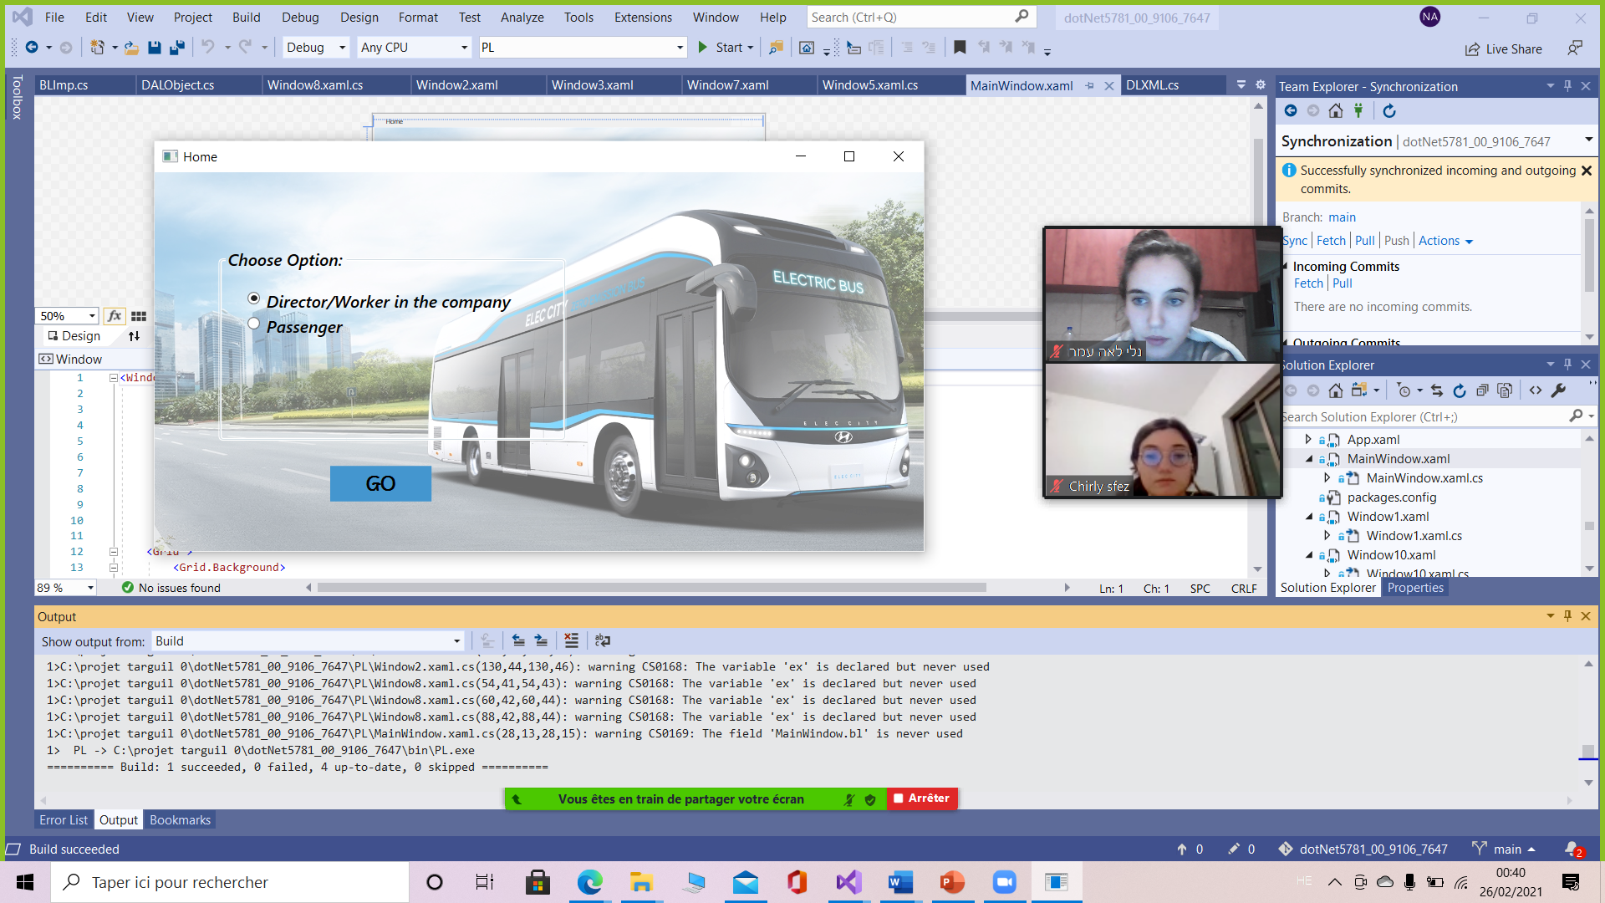

Window HOME:

You have 2 choices: Director/Worker or Passenger

If you choose director/worker, window 2 will be open.

If you choose passenger, window 1 will be open.

DIRECTOR/WORKER SIDE:

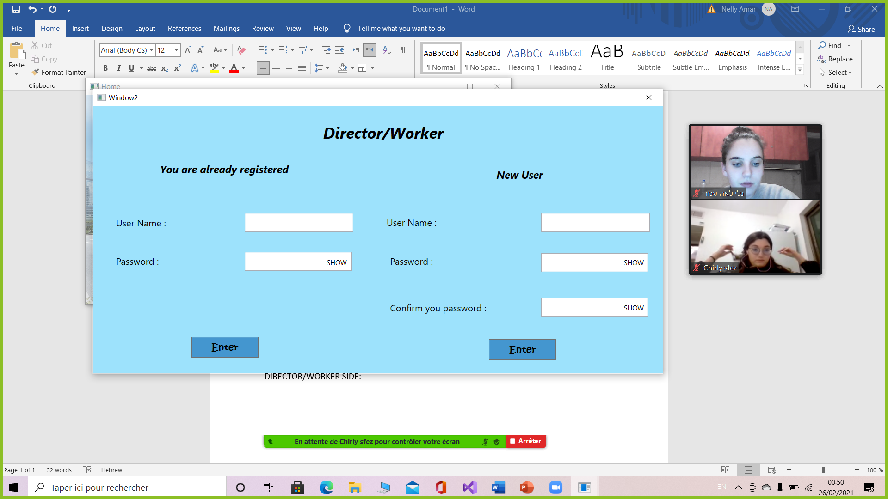

We have 2 possibilities or enter as registered or as a new user

We registered one user:

User Name: Chirly Sfez

Password: password

Functions:

CheckUserWorker- check if the User name entered and the password match

CheckPassword- check if the confirmation password and the password are equals

AddUser- register a new user

Exceptions:

* “input error” if the user name doesn’t exist
* “error password” if the user name exists but the password doesn’t match
* “Bad input” if you want to register a new user with user name which already exist
* “Not all the fields are completed”
* “Passwords don't match” if the confirmation password and the password aren’t equals
* “The user name already exists”

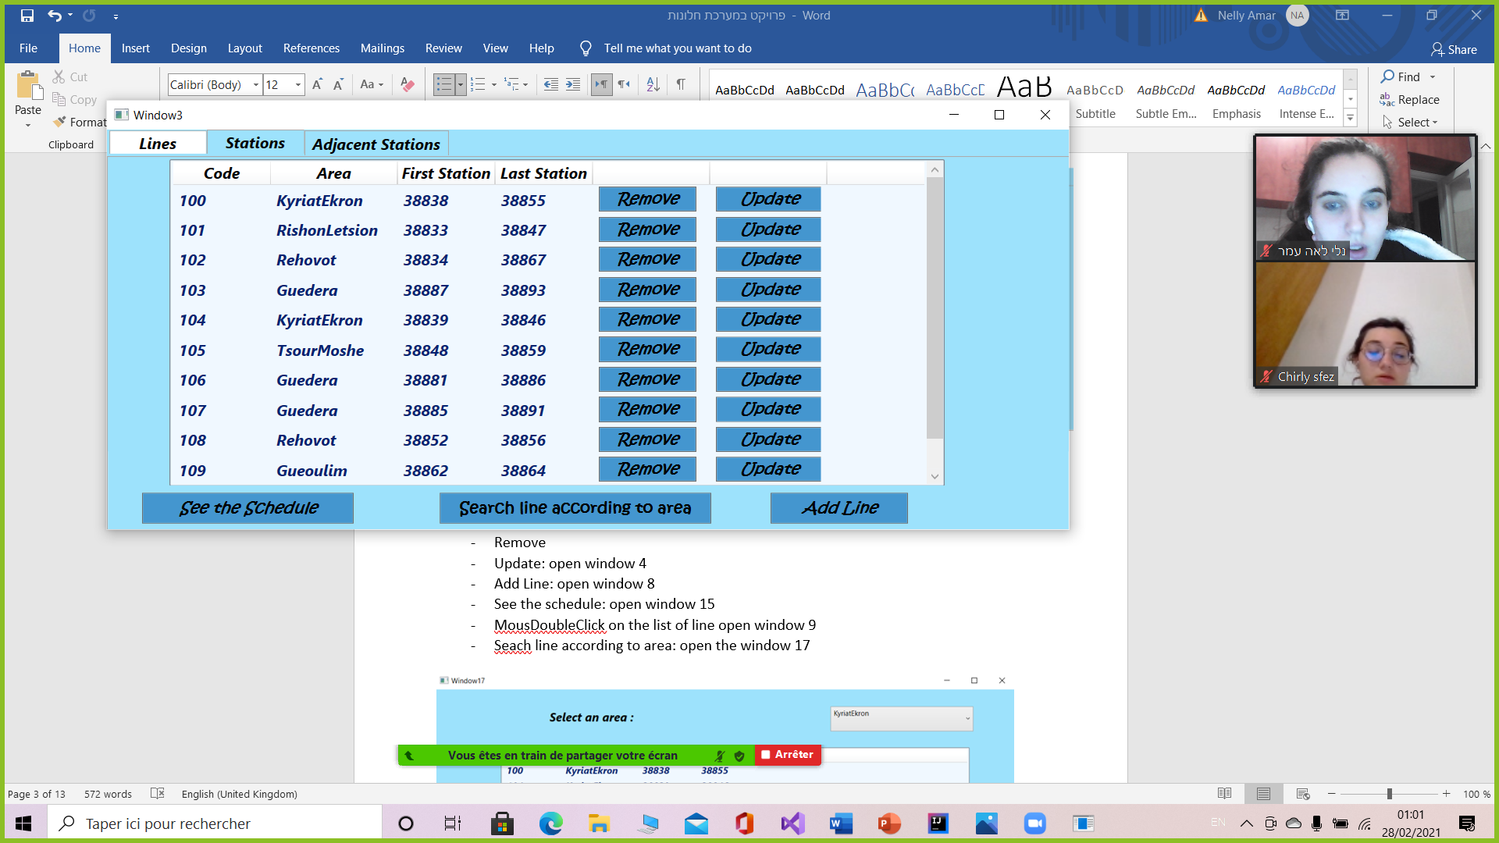

There is 3 tabs:

1. Lines:

Buttons:

* Remove
* Update: open window 4
* Add Line: open window 8
* See the schedule: open window 15
* MousDoubleClick on the list of line open window 9
* Seach line according to area: open the window 17

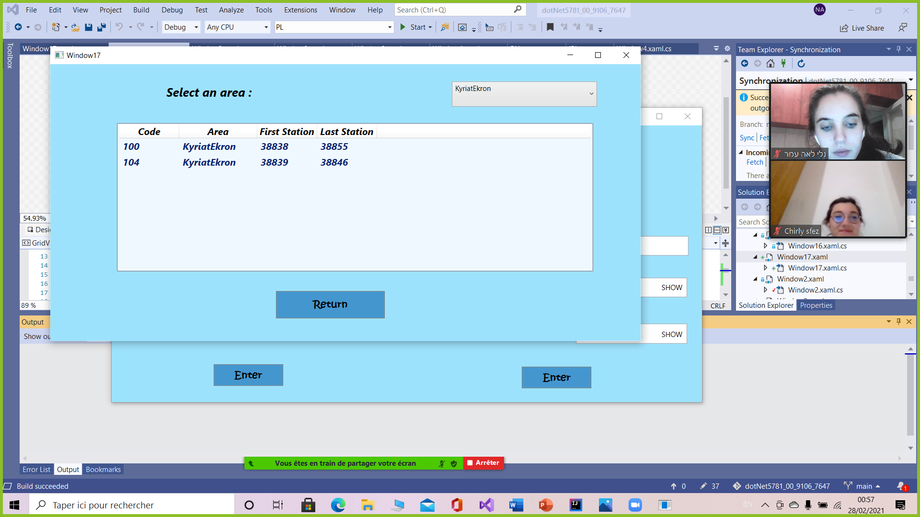

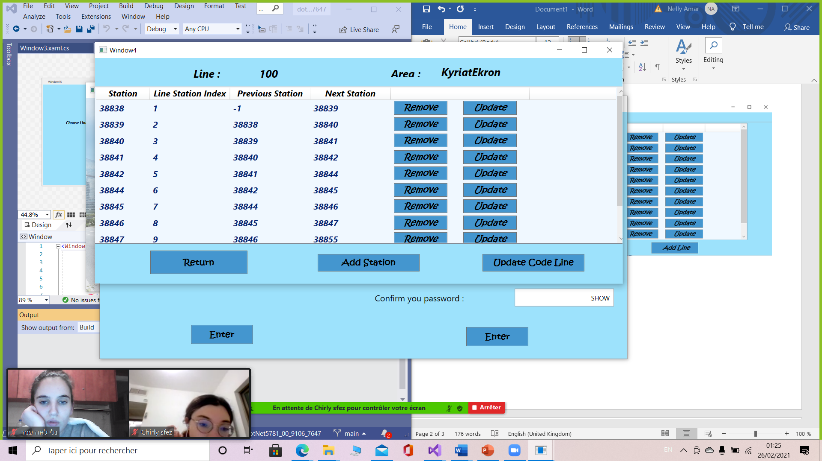Buttons:

- Remove

- Update: open window 5

- Return

- Add Station: open window 7

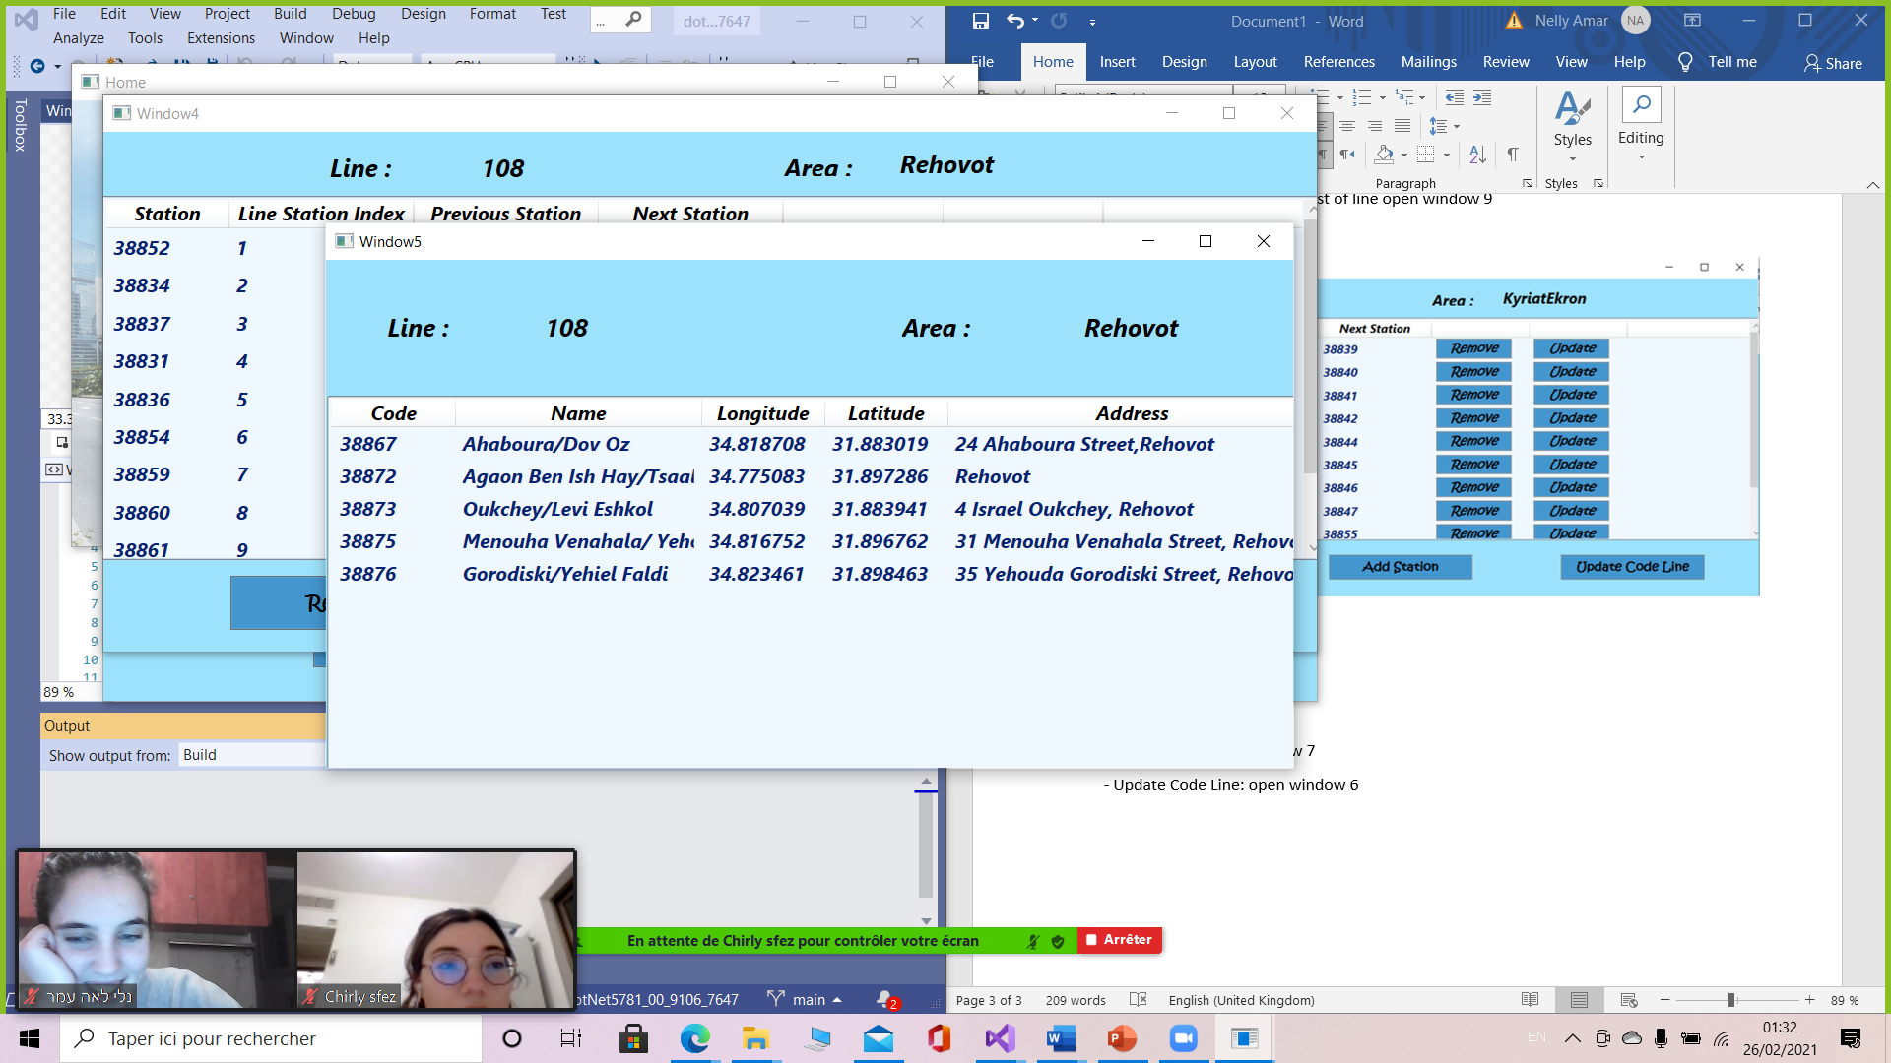- Update Code Line: open window 6

This window shows only stations that are in area’s line selected and that are not already in the line

MouseDoubleClick: replace the station previously selected with the station selected in the line

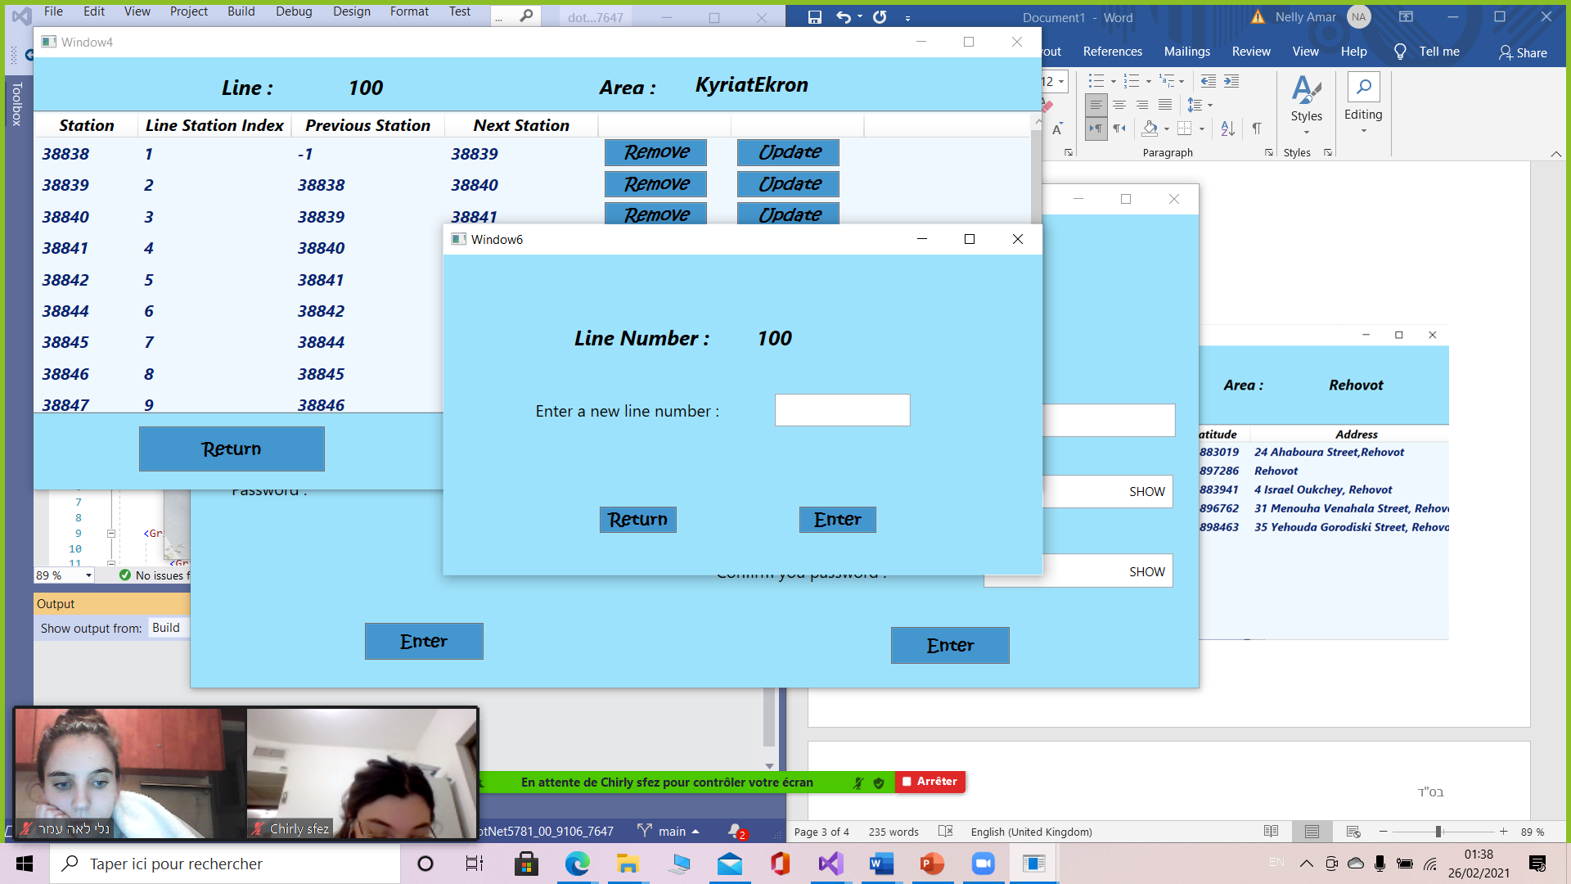

Exception:

- “The code field is not completed”

- “Bad Code Line”: if already exist a line with the same code and the same area

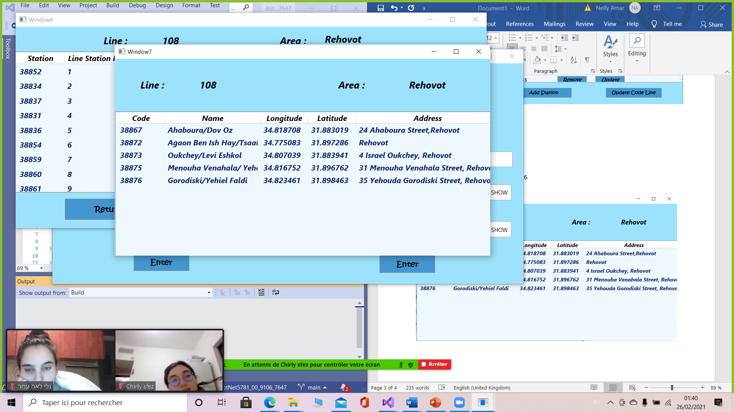

This window shows only stations that are in area’s line selected and that are not already in the line

MouseDoubleClick: Add the station selected in the line

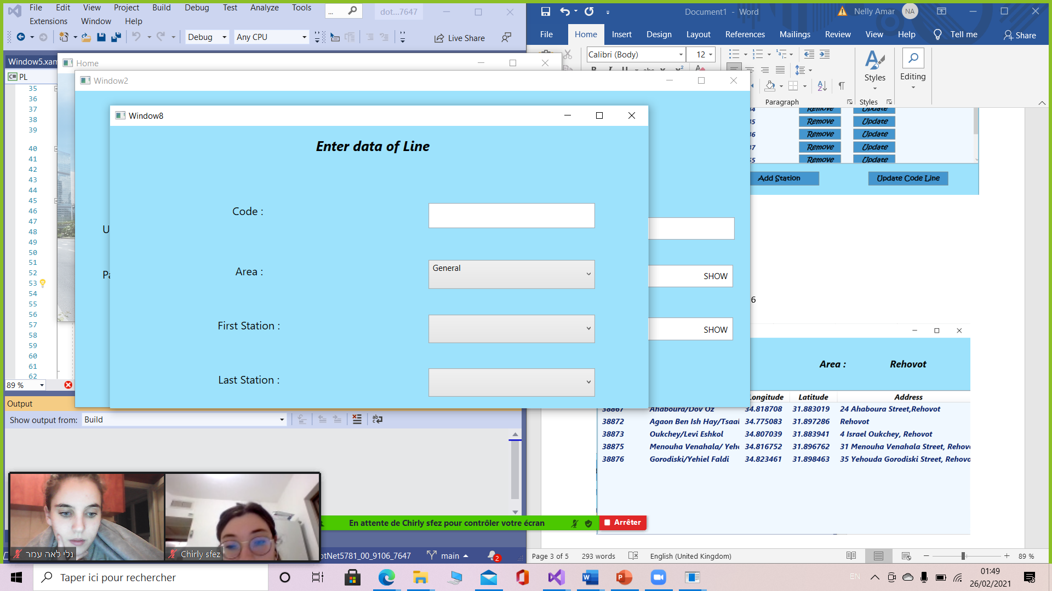

First Station show only stations that are in the area selected

Last Station show only stations that are in the area selected without the first station

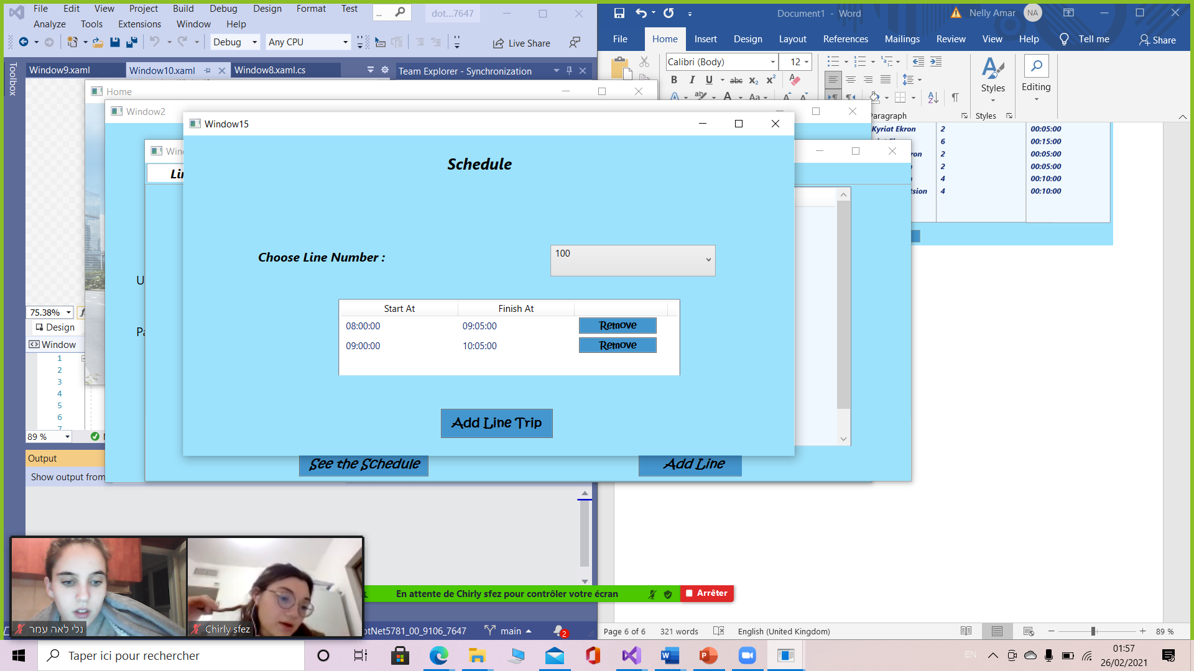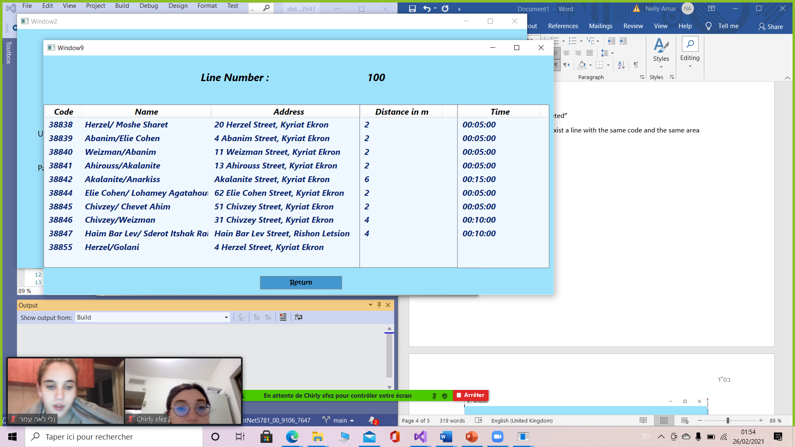

Button:

-Remove

-Add Line Trip: open window 16

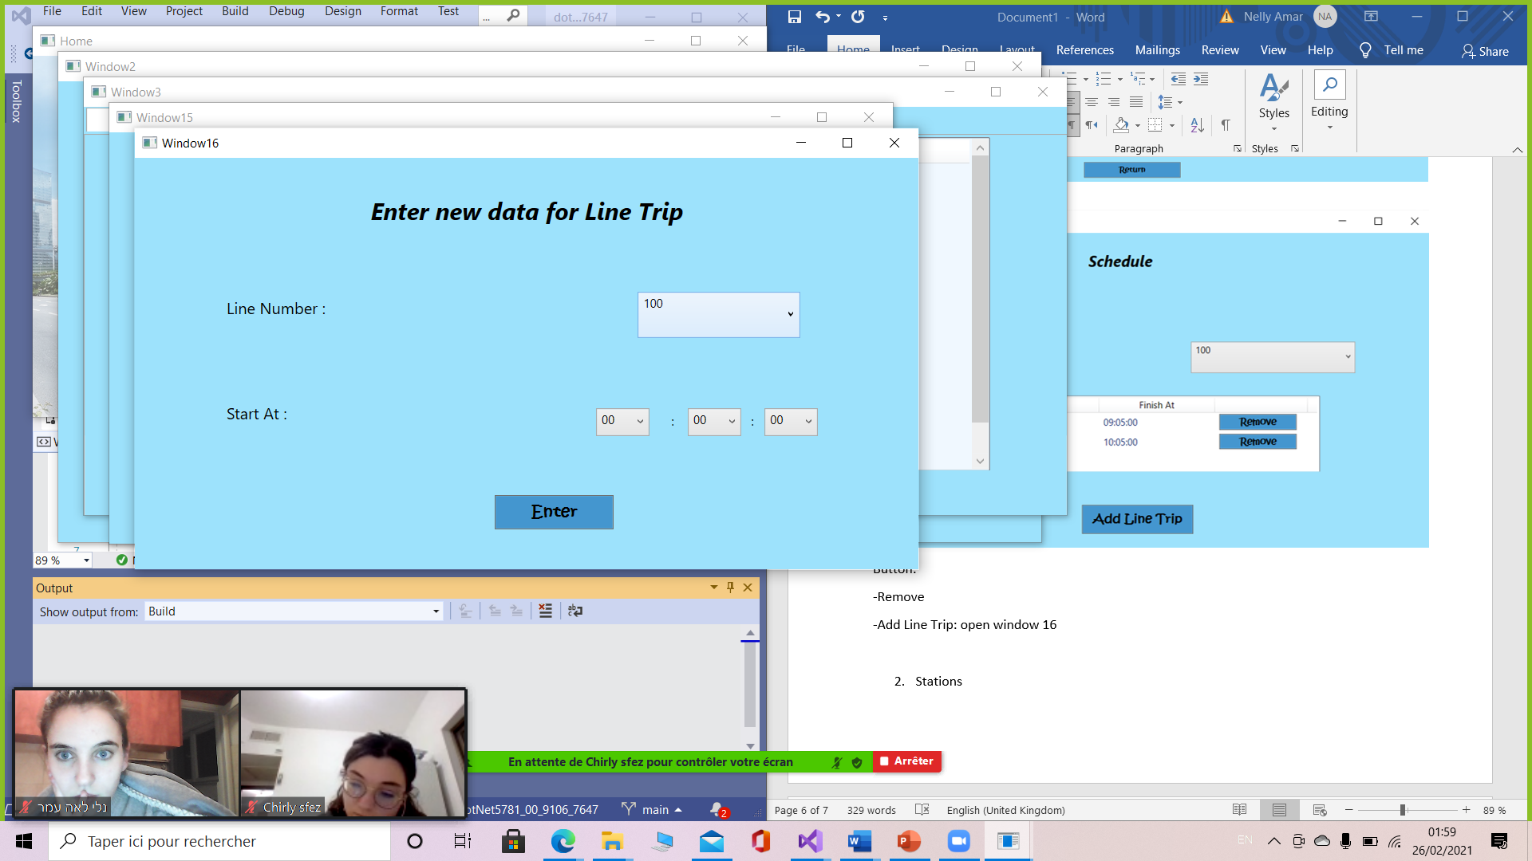

1. 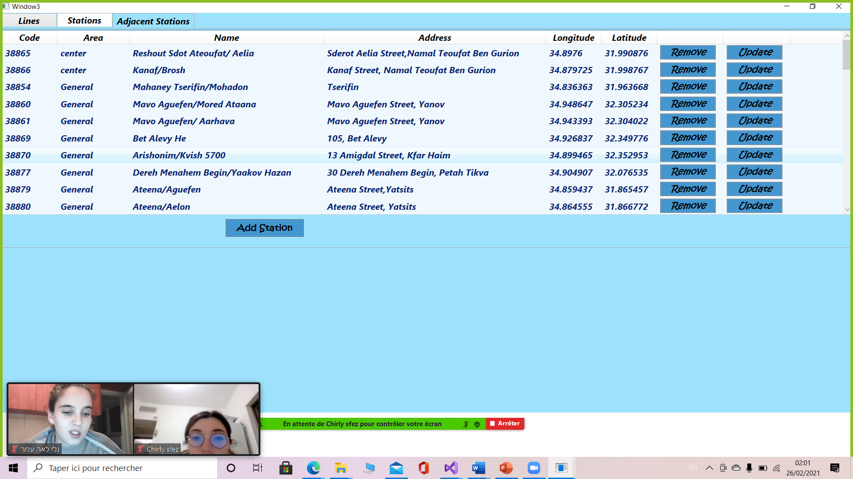Stations

Button:

* Add Station: open window 12
* Remove
* Update : open window 11
* MouseDoubleClick: open window 10

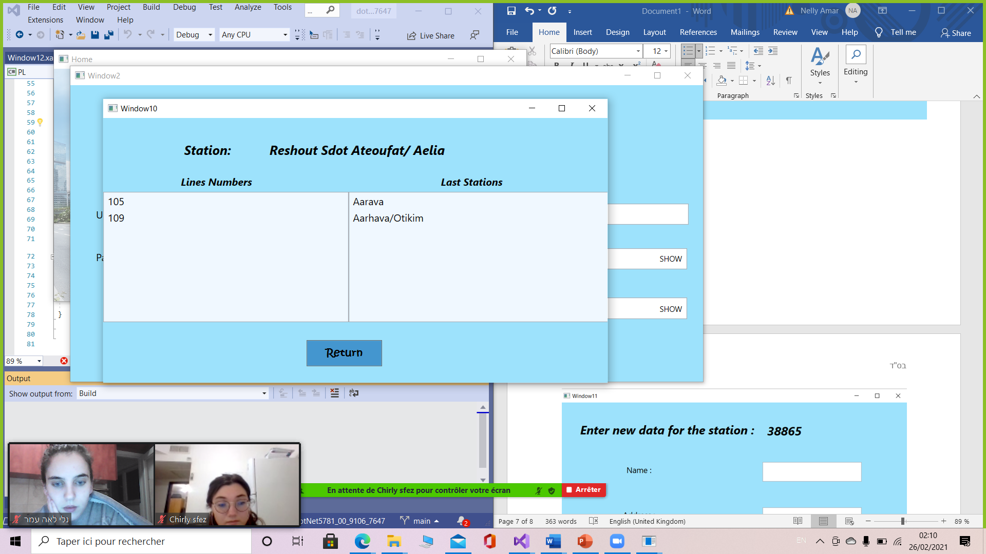

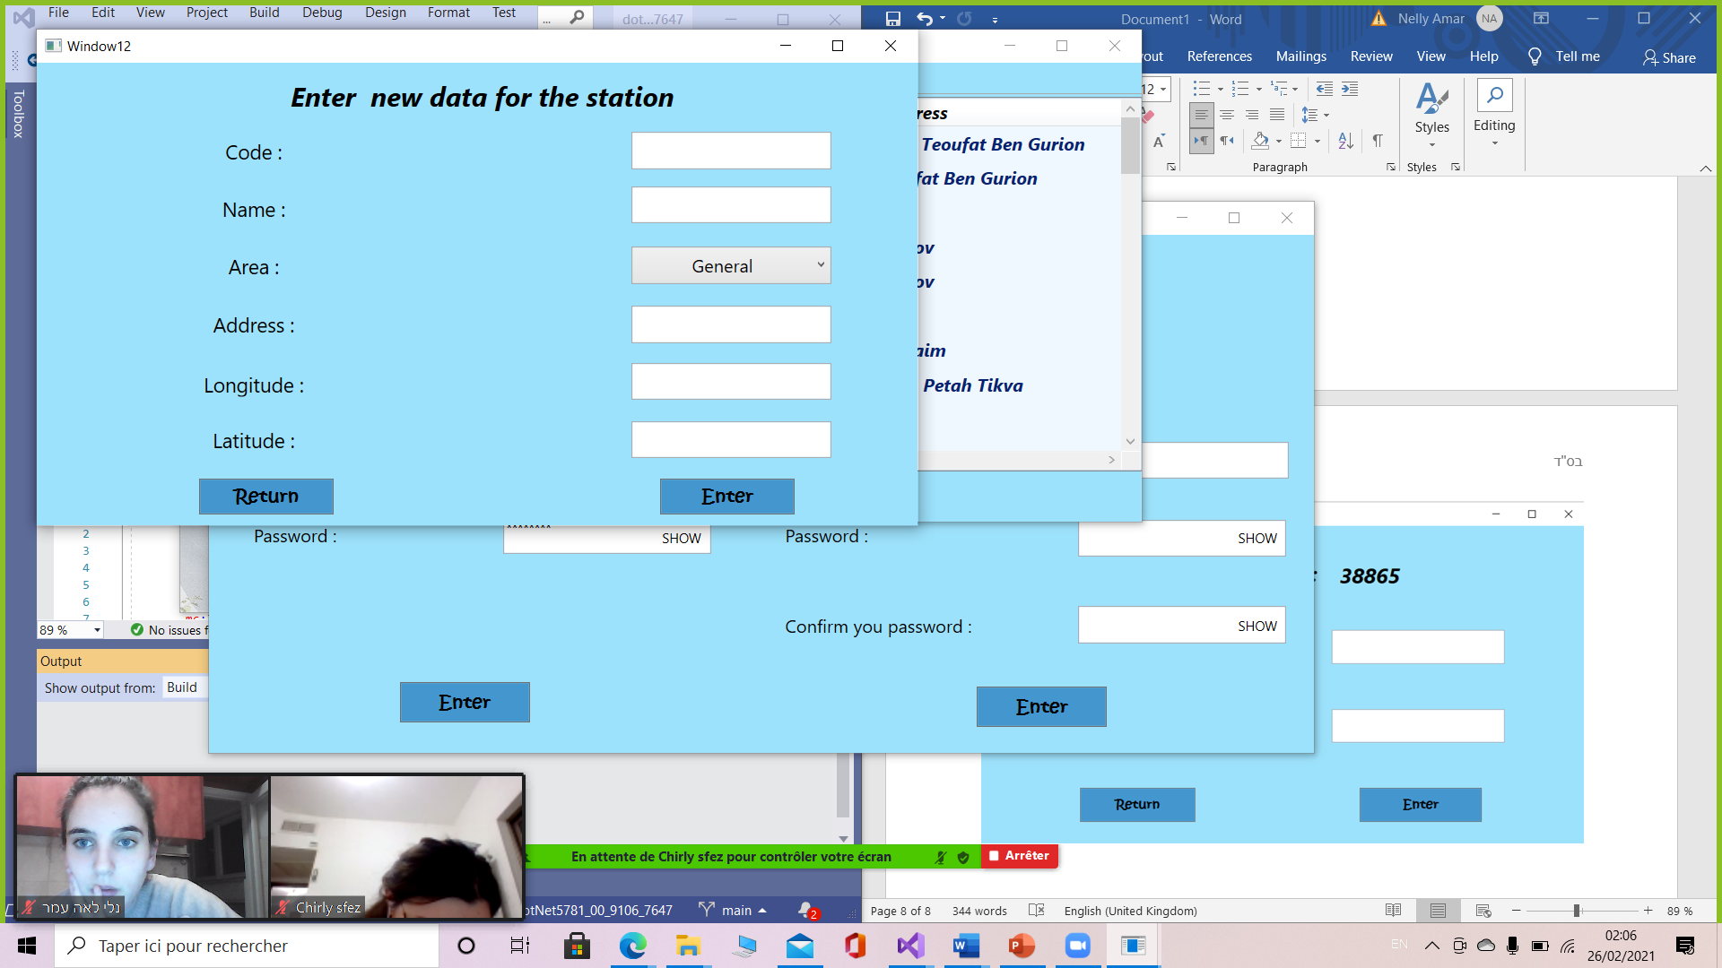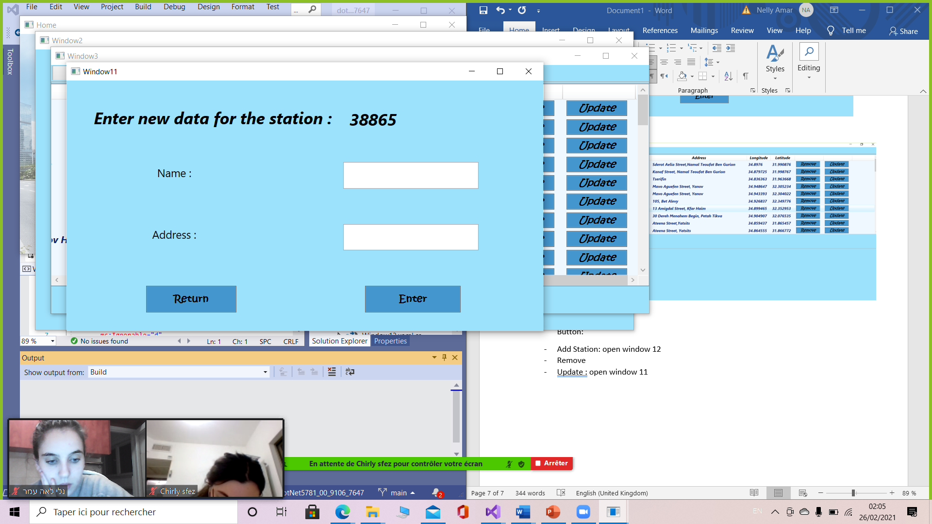

Exception:

* “ Bad Code Station”: if the code station already exists
* “Not All the properties are filled”

1. Adjacent stations

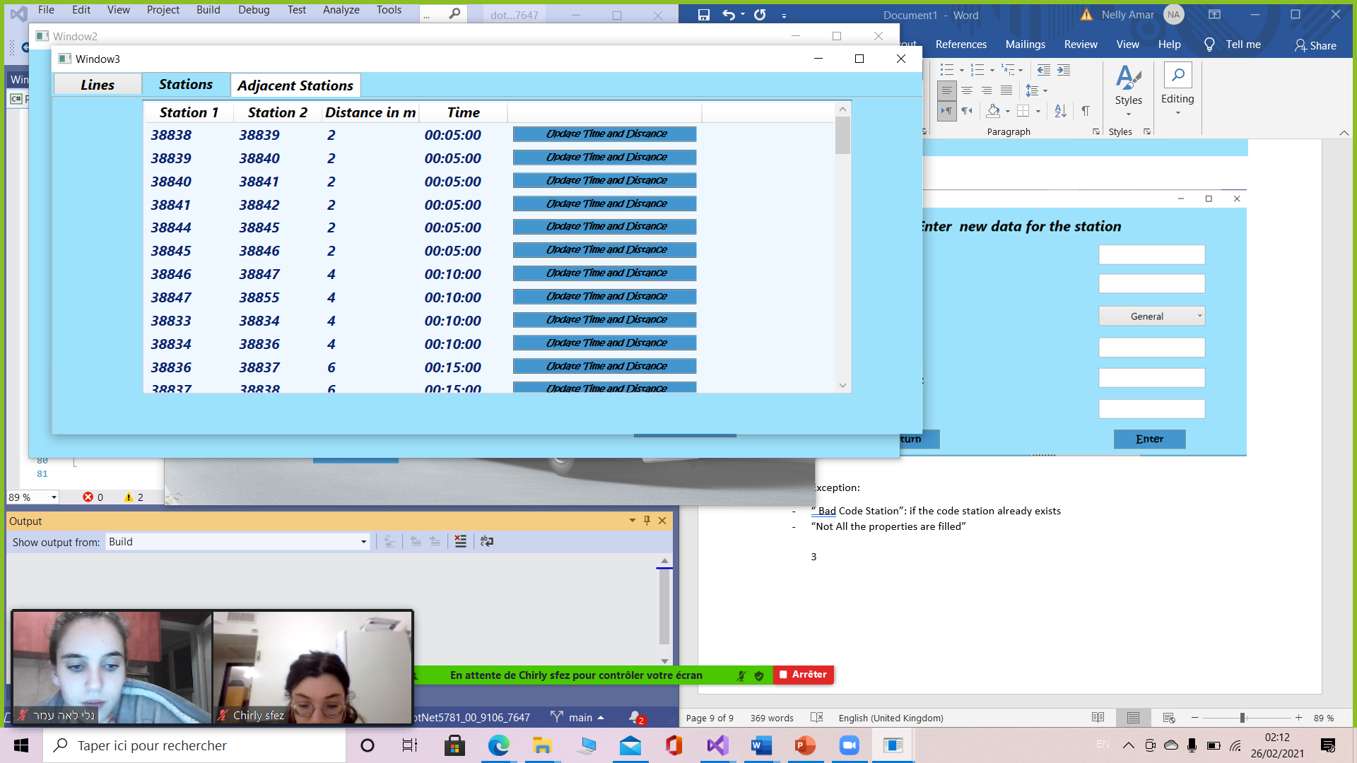Button:

Update Time and Distance: Update time and distance according to the longitude and latitude

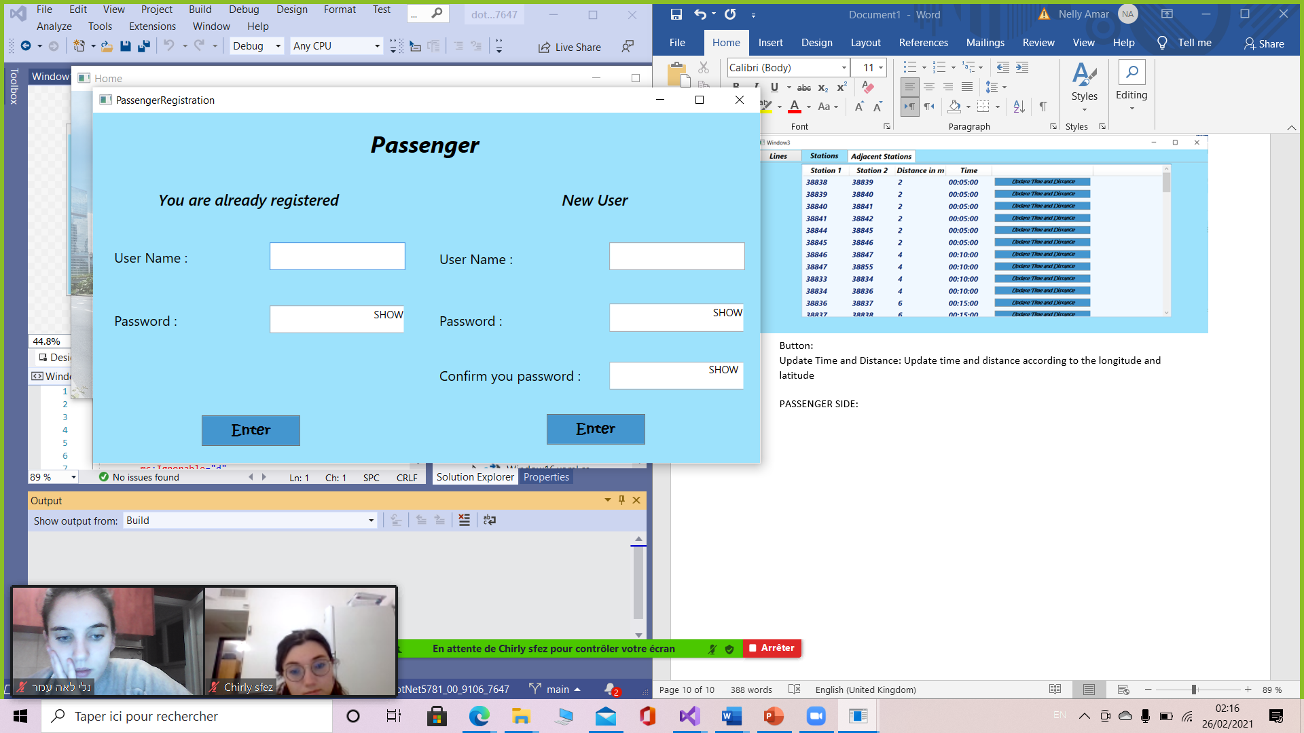PASSENGER SIDE:

We have 2 possibilities or enter as registered or as a new user

We registered one user:

User Name: Nelly

Password: 123456

Functions:

CheckUserPassenger- check if the User name entered and the password match

CheckPassword- check if the confirmation password and the password are equals

AddUser- register a new user

Exceptions:

* “input error” if the user name doesn’t exist
* “error password” if the user name exists but the password doesn’t match
* “Bad input” if you want to register a new user with user name which already exist
* “Not all the fields are completed”
* “Passwords don't match” if the confirmation password and the password aren’t equals

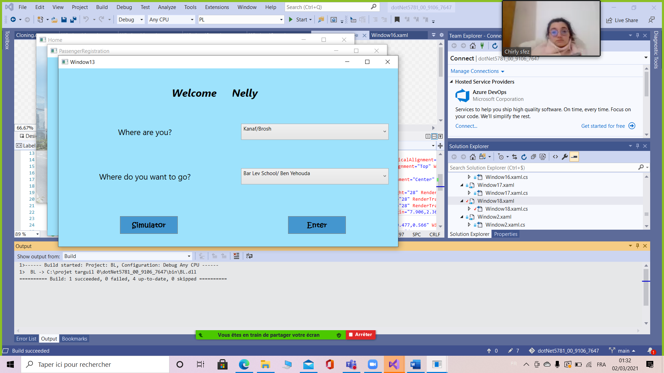“The user name already exist”

Where do you want to go show all stations without the first station selected (in Where are you)

Buttons:

-Enter: open Window 14

-Simulator: open Window 18

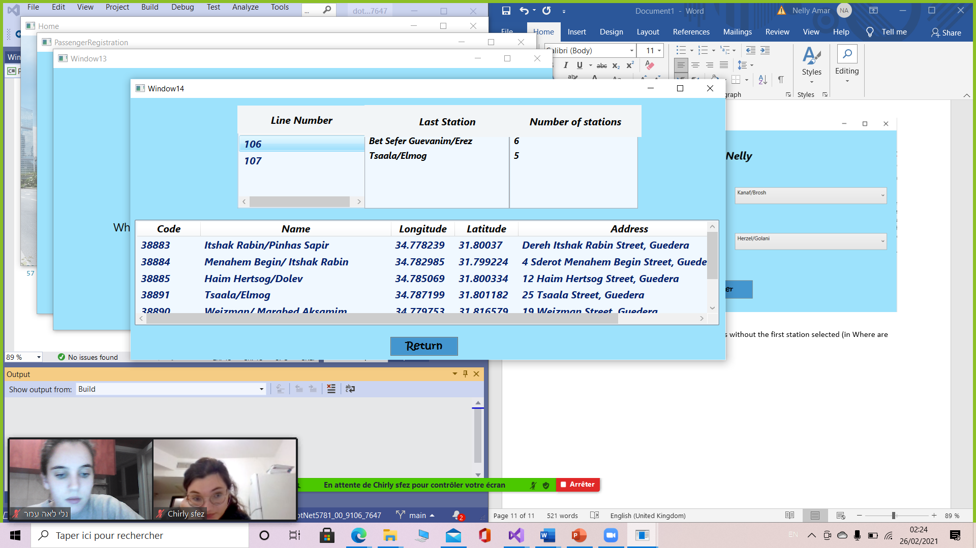

Show all the possible paths between the 2 stations selected with the line number, the final station and the number of stations in this path

MouseDoubleClick: show all the stations in the path

